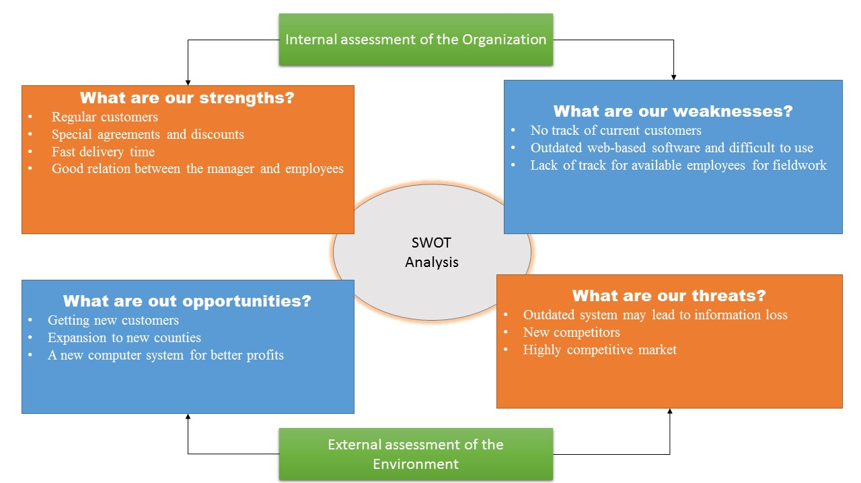**Strengths. Weaknesses. Opportunities. Threats.**

SWOT analysis offers internal assessment of the organization and external assessment of the environment. This analysis is used for planning the steps towards achieving the company goals by identifying its problems, strengths and opportunities.